|  |  |
| --- | --- |
| Ex No: 6  Date: 9/09/2024 | MNIST Autoencoder |

**Objective:**

The goal of the project is to build and experiment with a simple autoencoder using the MNIST dataset. The autoencoder reduces the dimensionality of input images to a lower resolution (32 units) and reconstructs them back to their original form (784 units). This helps in understanding how autoencoders can compress data and learn efficient representations.

**Code Explanation for simple_autoencoder:**

• The function simple_autoencoder(inputs) constructs a two-layer autoencoder:

* **Encoder**: Compresses the input from 784 units to 32 units using a dense layer with ReLU activation.

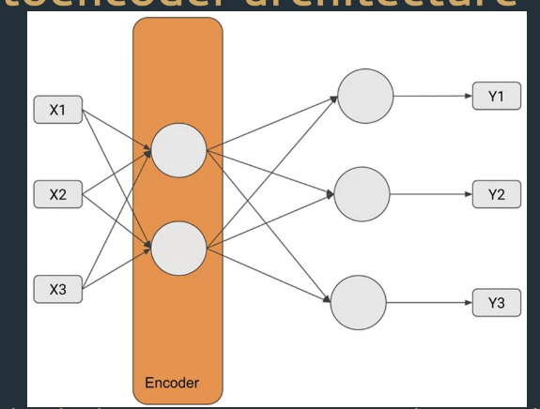

* **Decoder**: Reconstructs the input back to 784 units using a dense layer with sigmoid activation.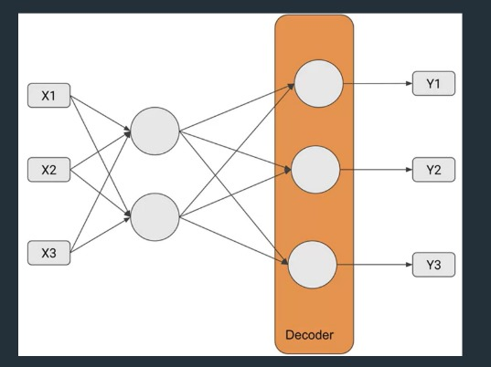

• Two models are built:

* **Encoder Model**: Extracts the compressed representation.
* **Autoencoder Model**: Performs the end-to-end encoding and decoding of the input.

**Results**

The project contains training results that show how well the autoencoder reconstructs the input images. The results typically include a comparison between the original and reconstructed images, as well as the loss or accuracy metrics during training. This provides insights into how well the model can compress and reconstruct data.

**Result Analysis:**

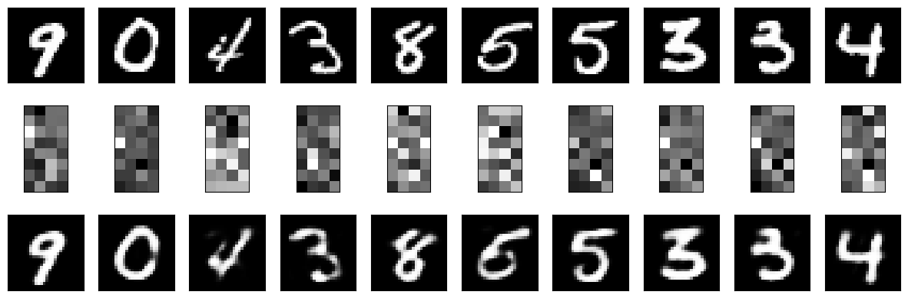

**Summary:**

The autoencoder developed in this lab demonstrates how neural networks can learn compressed representations of input data. Using the MNIST dataset, the autoencoder reduces the input size to a latent space of 32 units and successfully reconstructs the images.

**GitHub Link:**

https://github.com/Mithungowda6666/Deeplearning/blob/main/lab_6/Lab%20Encoder%201%20-%20Linear%20DISTRI.ipynb